Nama Peserta : Mulyadi

**Source code Git Hub :**

React JS : https://github.com/anakbawang13/pr-praisindo-reactjs

Node JS : https://github.com/anakbawang13/pr-praisindo-nodejs

1. Halaman Sign Up

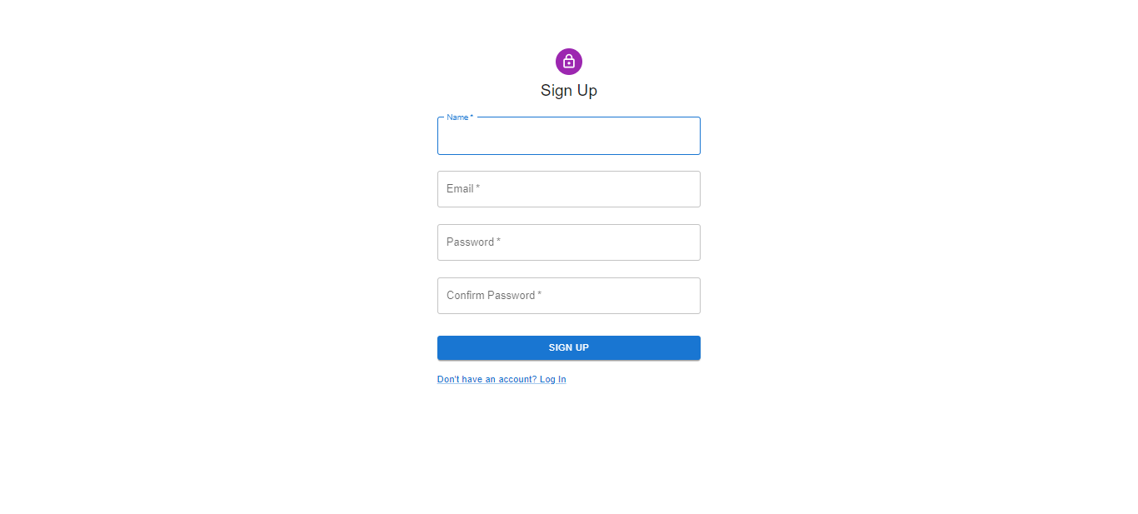

1. Halaman Login

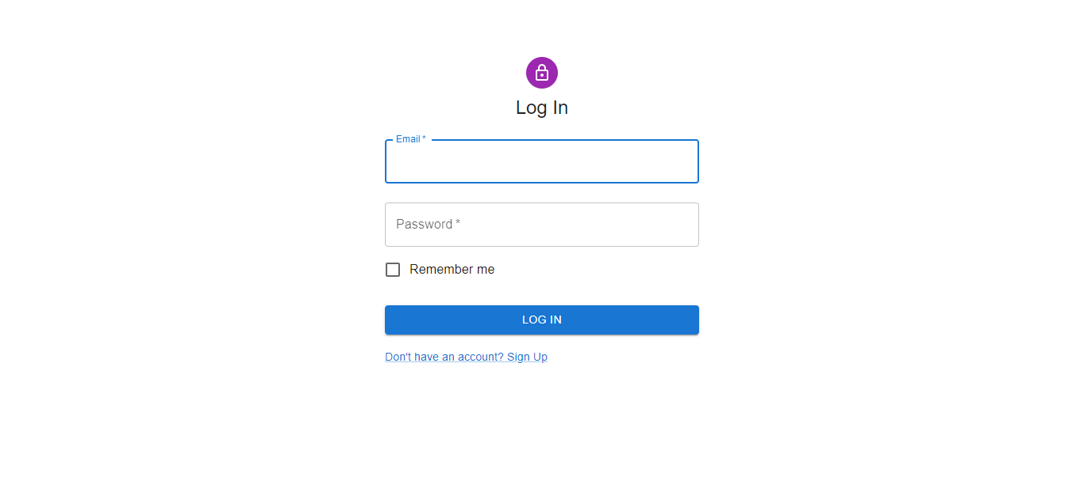

1. Halaman Home

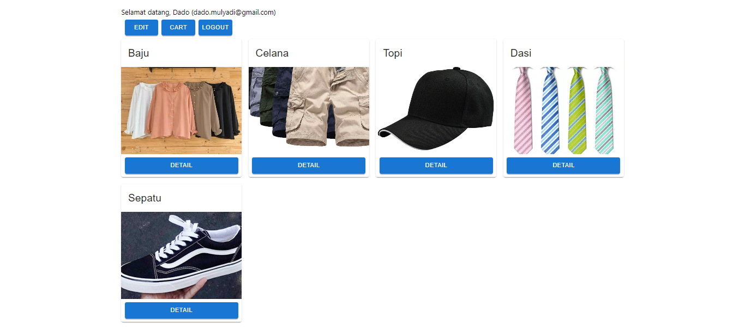

1. Halaman Edit User

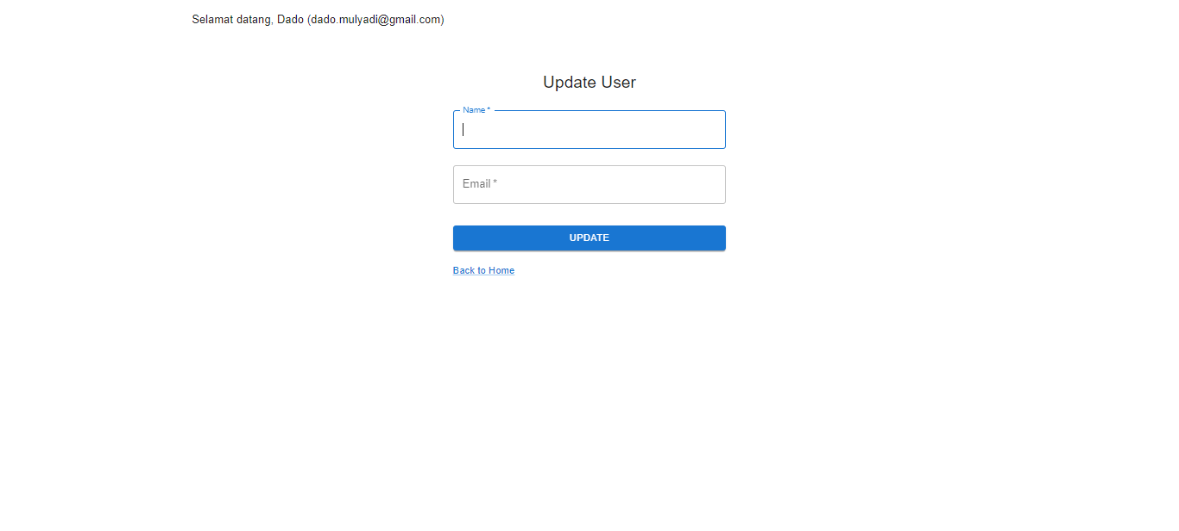

1. Halaman Detail Product

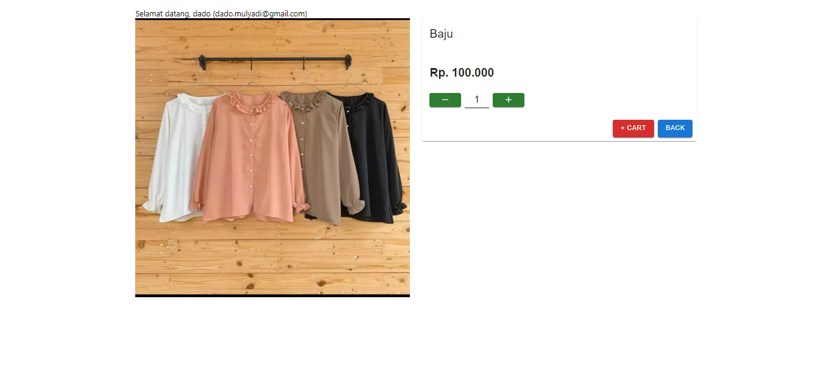

1. Halaman Cart

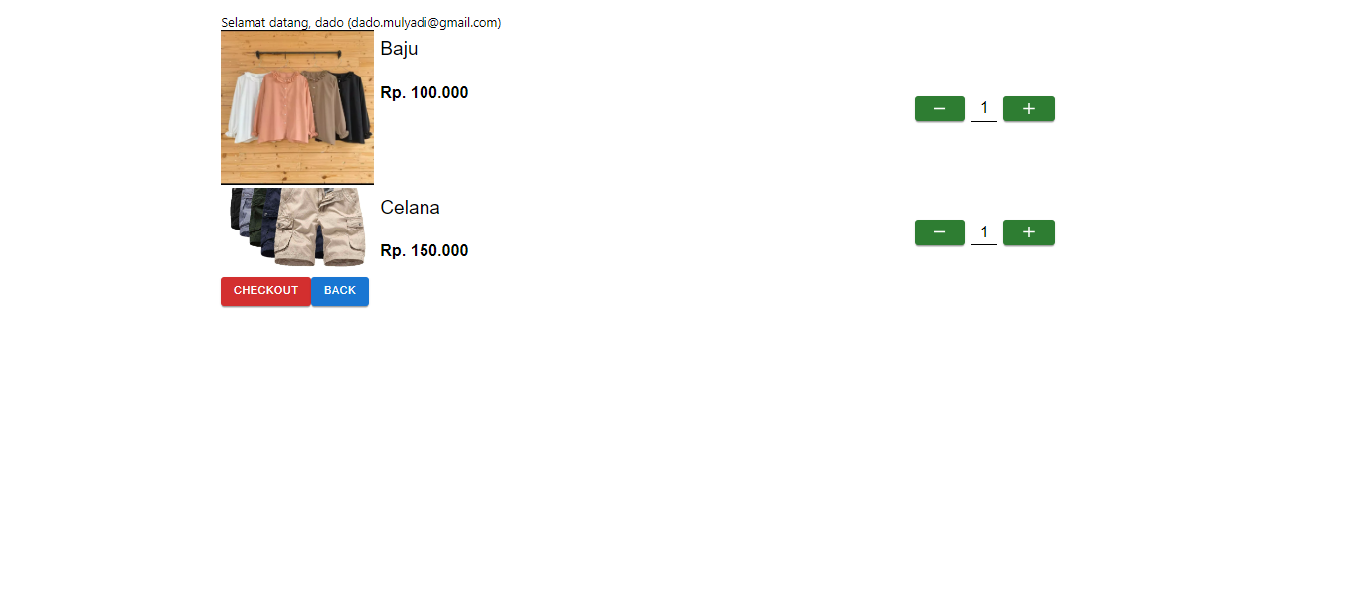

1. Halaman Checkout

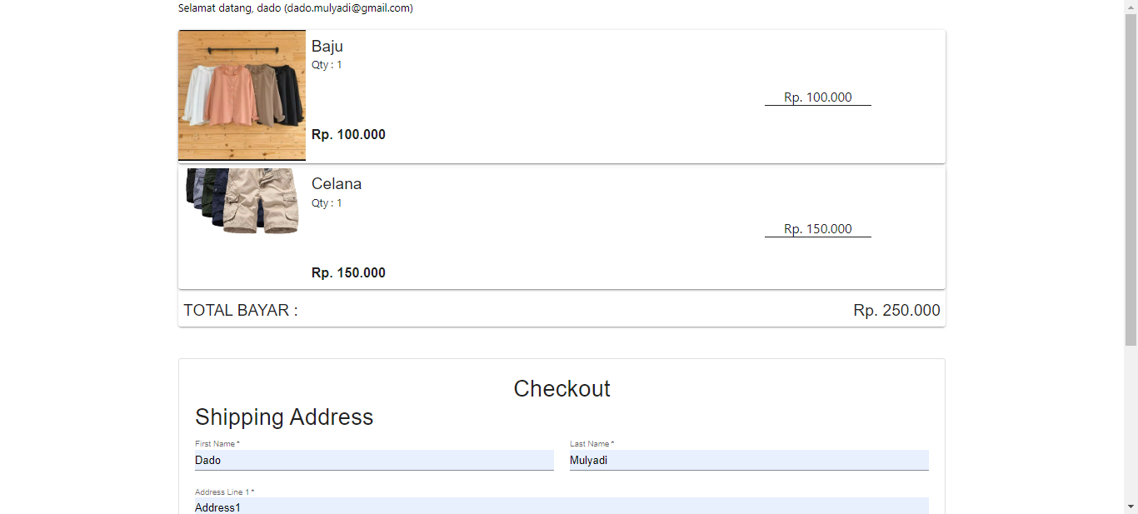

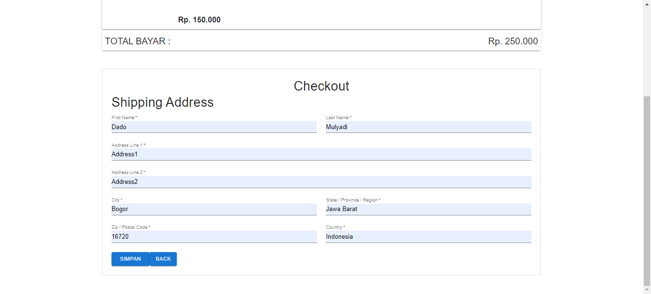

1. Data pada table

